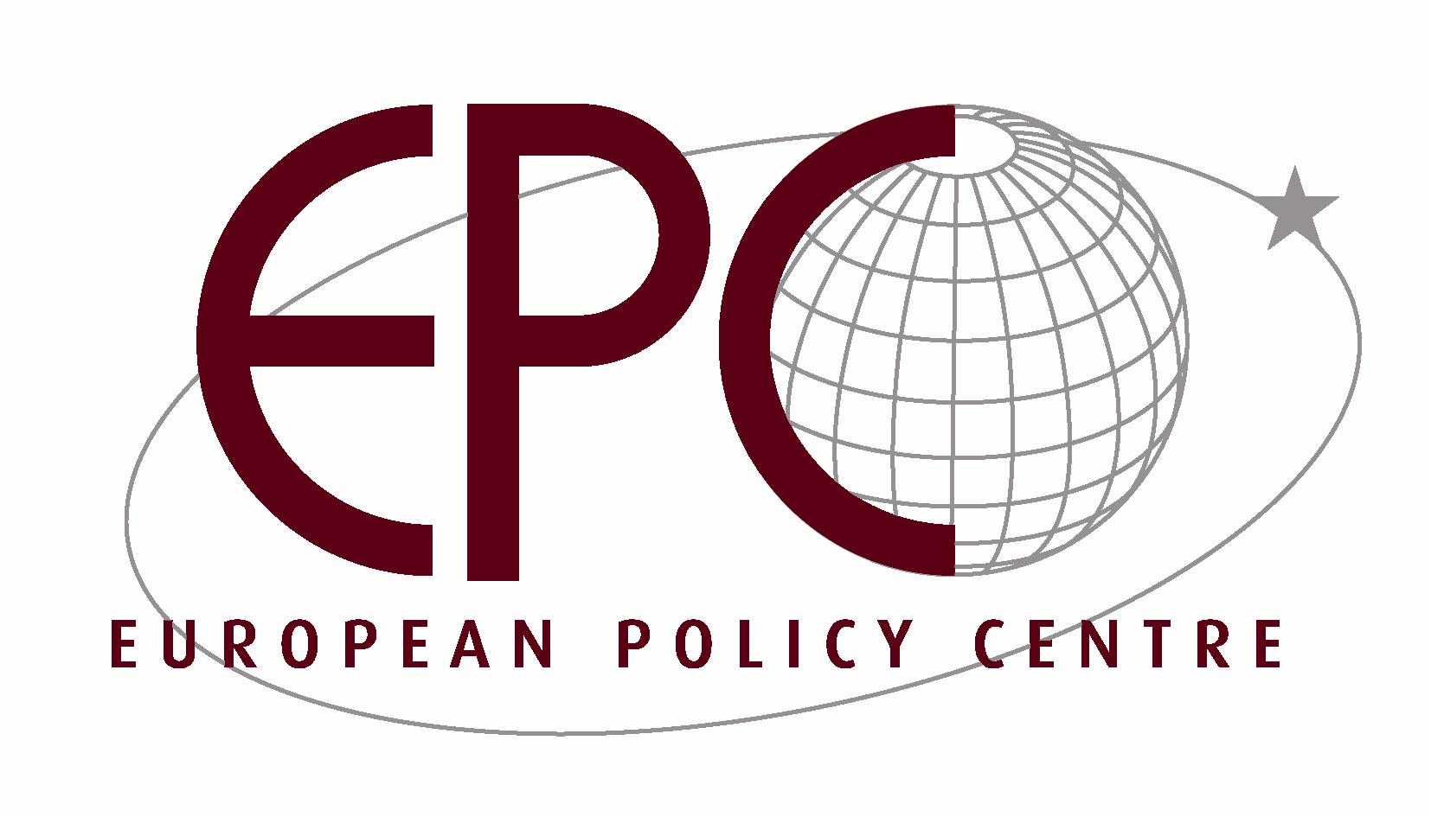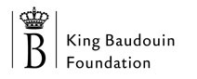

In cooperation with



Regularisation is not the only policy:

Ten Ways to Protect Undocumented Migrant Workers

Brussels, Friday, March 24th, 2006

DRAFT PROGRAMME

09h00 Registration and welcome coffee

09h30 Welcome and introduction by Thierry Timmermans, King Baudouin Foundation

09h40 Why should we be concerned about undocumented migrants in Europe?
Don Flynn, Joint Council for the Welfare of Immigrants

Overview of PICUM’s report: Ten Ways to Protect Undocumented Migrant Workers and workshop results and recommendations
Michele LeVoy, Researcher/Networker, PICUM

10h20 Panel Discussion I – Integration, Social Inclusion and Undocumented Migrants

Moderator: (tbc)
Keynote: DG Employment and Social Affairs (tbc)
Discussants: Ed Van Thijn, former mayor of Amsterdam and member of the Parliamentary Committee of the Council of Europe

11h20 Coffee break

11h45 Panel Discussion II – Undocumented Workers: Victims or Criminals?

Moderator: (tbc)
Keynote: Stefan Malomgré, Head, Social Inspection Unit, Federal Public Service of Employment, Labour and Social Dialogue of the Brussels Capital Region
Discussants: Catelene Passchier, European Trade Union Confederation; Bridget Anderson, Kalayaan and COMPAS, University of Oxford

12h45 Concluding remarks by Demetrios Papademetriou, President, Migration Policy Institute

PRACTICAL INFORMATION

Venue: Tulip Inn Hotel
Avenue du Boulevard, 17 1210 Brussels (opposite Metro station Rogier).
See map at: http://www.tulipinnbrusselshotel.com/Tulip_Inn_Brussels_Boulevard_Location.html

Language: English.

Fee: No registration fee.

Registration: The European Policy Center (EPC) will send out an invitation and registration form, which PICUM will forward to its network (not before March 10). Registration is possible until the day of the event.

Contact info: Michele LeVoy, Researcher/Networker
PICUM – Platform for International Cooperation on Undocumented Migrants
Gaucheretstraat 164
1030 Brussels
Belgium
Tel. +32/2/274.14.39
Fax +32/2/274.14.48
michele.levoy@picum.org
www.picum.org

