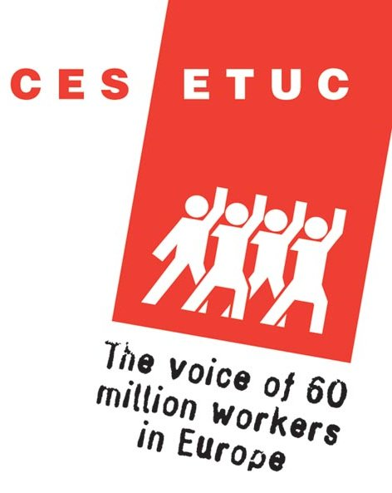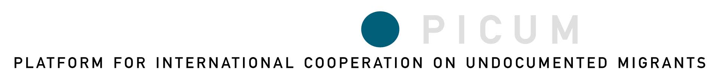

Protecting Undocumented Workers in Europe: Successes and Strategies

Brussels, Thursday, March 23, 2006
9:00 a.m. – 5:00 p.m.

This ETUC and PICUM event aims to bring together trade unions, NGOs, legal advocates, researchers, community groups and other professionals to share creative examples and strategies for protecting undocumented migrant workers from exploitation and abuse. This event builds on information gathered in PICUM’s report, Ten Ways to Protect Undocumented Migrant Workers (available online at www.picum.org).

Participants will hear examples of good practices in the plenary sessions, and then break into different groups to discuss relevant themes in the workshops. Each workshop will begin with a short presentation by an NGO or trade union with expertise on issues introduced in the plenary sessions. The working languages will be English and French. The plenary sessions will have interpretation, and the different workshop sessions will be held in English, in French, or in mixed languages (with interpretation).

DRAFT PROGRAM

9:00 – 9:15 Registration

9:15 – 9:30 Welcome and Introduction by Catelene Passchier, European Trade Union Confederation (ETUC) and Michele LeVoy, Platform for International Cooperation on Undocumented Migrants (PICUM)

Part I: Protecting undocumented workers in different sectors
Collecting data
Establishing constructive relations with labor inspection

9:30 – 10:30 Plenary session, moderated by Thierry Timmermans, King Baudouin Foundation

Keynote speakers:
Construction sector, the use of sub-contracting and undocumented workers:
União dos Sindicatos de Lisboa (USL) – tbc

Agricultural sector and undocumented workers
Nicholas Bell, European Civic Forum
Unions and NGOs working with labor inspection to uphold undocumented workers’ rights
Centro de información para trabajadores y trabajadoras extranjeros de las Comisiones Obreras (CITE-CCOO) – tbc

10:30-11:00 Coffee break

11:00-12:30 English language workshop, moderated by Nele Verbruggen, Migration Policy Group
Speaker: Marijke Bijl, OndersteuningsKomitee Illegale Arbeiders (OKIA)
French language workshop, moderated by Didier Vanderslycke, Organisatie voor Clandestiene Arbeidsmigranten (OR.C.A. )
Speaker : Denis Natanelic, Collectif de defense des travailleurs étrangers dans l’agriculture (CODETRAS)
Mixed languages workshop, moderated by Yongmi Schibel, Migration Policy Group
Speaker: T&G Union – tbc

12:30-2:00 Lunch in the ITUH building, 1st floor

Part II: Organizing and empowering workers
Mediation with the employer
Legal strategies to address exploitation and abuse

2:00 – 3:00 Plenary session, moderated by Hélisène Habart, Platform for International Cooperation on Undocumented Migrants (PICUM)

Keynote speakers:

Organizing, informing and empowering workers
SEIU representative currently based in Europe – tbc
Mediation and collective actions
Sindicato de Obreros del Campo (SOC) – tbc
Legal possibilities to assert undocumented workers’ rights
Marco Paggi, Associazione per gli Studi Giuridici sull’Immigrazione (ASGI)

3:00-3:15 Coffee break

3:15-4:45 English language workshop, moderated by Katrin Hugendubel, Solidar
Speaker: – tbc
French language workshop, moderated by – tbc
Speaker : Collectif des travailleurs/euses sans statut legal – Genève (CTSSL)
Mixed languages workshop, moderated by Johan Wets, Higher institute for labor studies, KULeuven
Speaker: – tbc

4:45-5:15 Concluding remarks – tbc

PRACTICAL INFORMATION

Venue: International Trade Union House (ITUH) – 1st floor

Boulevard Roi Albert II, 5 1210 Brussels, Belgium

The ITUH is within walking distance of the Brussels North train station and Metro station Rogier. See map at: http://www.etuc.org/IMG/jpg/map.jpg).

Languages: English and French. The plenary sessions will have interpretation, and the different workshop sessions will be held in English, in French, or in mixed languages (with interpretation).

Fee: €20 (includes lunch at the conference facilities).
Please pay in cash at the conference venue (we regret that payment by credit card or debit card is not possible).

Registration: Form available online at www.picum.org. Deadline: March 13, 2006.

Contact info: Michele LeVoy, Researcher/Networker
PICUM – Platform for International Cooperation on Undocumented Migrants
Gaucheretstraat 164
1030 Brussels
Belgium
Tel. +32/2/274.14.39
Fax +32/2/274.14.48
michele.levoy@picum.org
www.picum.org

