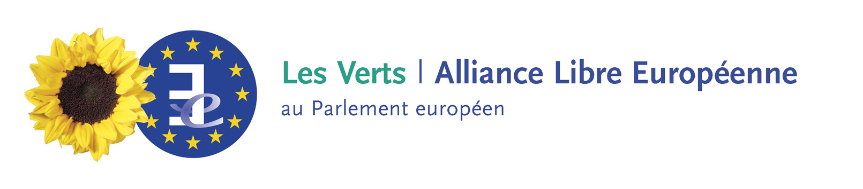

CONFERENCE PROGRAM (draft)

ISLAM in EUROPE or ISLAM of EUROPE?
European Parliament
11 December 2002
09.30-13.00 room A1G3
15.00-18.30 room A1G2

08.45 - 9.30 Registration

09.30 Opening and welcoming speeches
Anna Diamantopoulo*, Employment and social Affairs Commissioner, European Commission
Renzo Imbeni*, Vice-President, European Parliament
Alima Boumédiène-Thiéry, Member, Greens/EFA, European Parliament

10.00 Introduction: Mohamed Ahmad Sherif, Secretary General, World Islamic Call Society

10.15 - 13.00 HISTORICAL BASES and EVOLUTION OF ISLAM
Moderator: Mohamed Ghaleb BENCHIR, Journalist
- The Ottoman period: Dr Driss El-Harir, UNESCO, Historian
- The Andalous period: Rodrigo Aljayas or Dr Ahmed Toufik*, Religious affairs' Minister, Morocco
- Muslims in Europe and Islam modernisation: Prof. Dr Karoui, Deutsch-Arabisches Zentrum
- Women in Islam's history: Faouzia El Ashmaoui, Geneva University
- Women in Islam nowadays: Asmaa Anne-Sophie Rold, Malmö University
- Ali Daddy, Writter, Belgium

DEBATE 11.30 - 13.00

13.00 - 14.30 Lunch

14.30 - 18.30 REPRESENTATION AND PERSPECTIVES FOR ISLAM IN EUROPE
Moderator: Nacera Ben Marghnia, President, Muslim Women and Families in France
- Belgium Muslims Executive : Nordine Malou Jahmoum, President
- Islam representation in Austria : Anas Scharfa, President, Islamic Organisation in Austria
- Islam representation in Germany,
- Islam representation in the United Kingdom, a speaker from the Muslim Consult British
- The organisation of Islam in France, Dr Ahmed El-Alami, Rector Mosque in Toulouse, France
- How youth Muslims perceive Islam in Europe? Muslim Youth and Student Organisations
- Islamophobia in Europe, Beate Winkler*, Director, European Monitoring Centre against Racism and Xenophobia
- What are the perspectives for Islam in Europe? Prof.Tariq Ramadan, Fribourg University, Switzerland

DEBATE 16.30 - 18.00

18.00 Conclusions: Bechari Mohamed, Secretary General, European Islamic Conference

Closing session: Philippe Schillings (ofm), National Director for Migrations, Bishops' Conference in Belgium
Alima Boumédiène-Thiéry, Member, Greens/EFA, European Parliament

18.30 Cocktail
Word from Dr Ataman Aksöyek, Director, CRE

