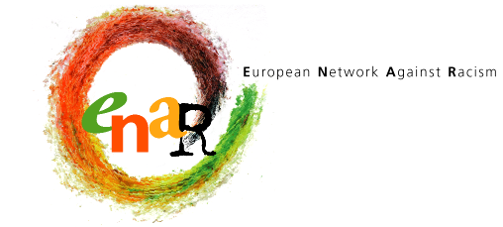

EUROPEAN NETWORK AGAINST RACISM

PRESS RELEASE

Brussels, 22 April 2002

FAR RIGHT PUSH IN FRANCE: A WAKE-UP CALL FOR EUROPE

In France’s presidential elections Jean-Marie Le Pen, the founder and leader of the extreme right National Front party, gained 16.86% in the first round of voting on 21 April, thereby securing his place in the two-candidate run-off against the incumbent President Jacques Chirac.

A network of more than 600 NGOs working to combat racism in all the EU member states, the European Network against Racism (ENAR), expresses its deep concern at this unprecedented push to the extreme right in the French political landscape. In a country that once brought forward the inspiring ideas of “liberty, equality, fraternity”, there should be no major political role for someone who blames immigrants for high unemployment and urban violence and once notoriously described the Holocaust as a “detail of history”.

This political development comes at a moment when extreme right political parties are on the rise all over Europe. Some ten million people across the EU voted for parties of the extreme right in the last European parliamentary elections.

ENAR calls on all democratic political parties in the European Union to do their utmost to combat racism and xenophobia that provide a feeding ground for the current upsurge of extreme right political forces. ENAR also invites European political parties to sign the “Charter of European Political Parties for a Non-Racist Society”, which paves the way to rid political campaigning and discussions of the scourge of racism and xenophobia.

European Network against Racism:

http://www.enar-eu.org/

Charter of European Political Parties for a Non-Racist Society: http://eumc.eu.int/projects/charter/

For further comments, ENAR can be reached at:

István Ertl, ENAR Information Officer
43 rue de la Charité
B-1210 Bruxelles
Phone: 32 (0)2 229 35 71
fax: 32 (0)2 229 35 75
e-mail: istvan@enar-eu.org
http://www.enar-eu.org

