
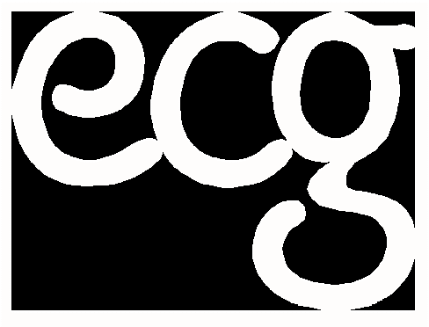
European Contact Group in the Czech Republic
&
European Contact Group International Network

Invite you to:

Women’s values and spirituality as a key to tolerant, multicultural and multireligious Europe-
Everyday life of women from ethnic minority groups in Europe
International seminar for migrant women and women from ethnic minorities living in Europe
20.4. – 24.4. 2005

Kostelec nad Cernymi Lesy (near Prague)

Czech Republic
- Background information
Migration, minorities, multiculturalism, integration, cultural tradition, discrimination, xenophobia, exclusions.....and much more of these issues are being discussed in Europe nowadays. Migrant and ethnic minorities face many difficulties while living in Europe no matter whether they live in EU or non-EU countries. Despite the existence of conventions on human rights, EU directives on racial and employment equality, and so on, there will be a long process to achieve an equal and just multicultural society in Europe. Those who can significantly contribute to its development are certainly women from minorities and various ethnic groups. They play a key role in their family and raise children (new generations).Their values, everyday life experiences, and cultural and spiritual backgrounds can bring important enrichment to European society. Therefore their voices should be heard. They should be able to comment on current developments and give evidence of real situation in terms of discrimination and unjust treatment. They should also be given an opportunity to meet other women living in different countries and compare their conditions, their living strategies, and their cultures. In many ways, they might symbolise “a mirror” to governments and EU policy makers, and reflect on the impact of anti-racial and equality policies on the everyday lives of minorities. For all these reasons EKS & ECG organises international meetings of women from ethnic minorities and migrant groups. There have been three such meetings so far: Paris (1995); Antwerp (1998) and Glay (2001). The following meeting will take place, for the first time, within Central and Eastern Europe. It brings a chance to gather women from the EU, new member states, and non-EU states and enable them to compare and discuss the roles and positions of women from ethnic minorities in different parts of Europe.

- Aims of the seminar
- Inform about and discuss fundamental human and social rights and share personal experience with their applications by relevant bodies and organisations (e.g. state institutions, NGOs, schools, local governments, healthcare services) in different European countries (these will be summarised in a memorandum to the EU commission)
- Share life stories and experiences with racism, discrimination and xenophobia
- Compare the situation and role of migrant women and women from ethnic minorities in various European countries (comparison of EU/new member states/ other states)
- Describe and reflect on the role and influence of spirituality and values on facing reality and discover how women’s cultural and religious resources help them to transform their situation
- Organise workshops focusing on practical life strategies in majority society.
- Visit organisations as well as representatives of ethnic minorities in the Czech Republic (refugee camps, integrated families, NGOs, etc).
- Discuss needs, suggestions, and examples of good practice
- Promote international dialog and cooperation between women’s groups and NGOs working with minorities in different European countries

  - Location of the seminar
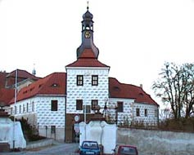
Kostelec nad Cernymi Lesy is a small town 30km east of Prague, the capital city of the Czech Republic. The seminar will take place in the former “chateau” which belongs to the Czech Agricultural University. The building is not a standard campus. It serves as a centre for vocational training. Therefore there will be almost no students and the whole place will be available for seminar purposes. Participant will be accommodated in double/triple rooms. The whole place is cosy and safe.

- Programme
The programme is designed to enable participants to fully contribute and bring their own visions, experience and ideas. It includes group work, discussions in the plenary, workshops, encounters with local representatives of minorities (visits), informal sharing, etc. The detailed description of the programmes is attached.

- Languages
English – Dutch – Russian - Czech
Simultaneous interpreting during the whole seminar guaranteed.
(We may alter the languages according to the needs of participants.)

- Participants
The seminar is meant only for women. They should be:
- Women from migrant & refugee communities & ethnic minorities who are living in Europe and (preferably but not necessarily) are involved in grassroots or self-support women’ groups (we welcome women from EU as well as non-EU countries such as Moldova, Byelorussia, ex-Yugoslavia, Ukraine etc.)
- Women activists or community workers who are directly involved in working with grassroots migrant & refugee & minority women.

We would like to emphasise that the seminar is meant for grassroots women who have life experience relevant to the seminar theme. The seminar is not intended as an academic event.
We also welcome small groups of 2-3 women coming from one community, neighbourhood or organisation. Mutual experience and inspiration in the seminar might empower them to develop new activities back home and establish international co-operation. However this is not a necessity and individuals will also be accepted.

The final number of participants will be about 40. They are expected to be involved in the follow up process and further co-operation and networking. Only these participants who stay for entire seminar will be accepted.

- Costs
The seminar fee is divided into four different levels, which are dependent on the financial capabilities of participants or their organisations. The minimum fee is set to make participation in the seminar accessible for any individual or activist whose organisation does not have funds for international activities. EKS also has limited funds to cover the travel expenses of several participants if they use the cheapest means of transport.
If you require financial support for the seminar fee or transport, specify it in your booking form. Please, do not book your tickets before receiving a confirmation of financial support from the EKS office.

Normal price: 220 € | For those whose organisation is funded/ who can pay on their own behalf
Reduced price: 100 € | For those who cannot manage the Normal Price. By agreement beforehand.
Economy price: 50 € | For those who cannot manage the Economy price. By agreement beforehand.
Minimum Fee: 20 € | We hope that all the participants can pay a contribution to living costs. By agreement beforehand.

- Notes
If you need a Visa, please contact the office as soon as possible for a letter of invitation.

The EKS does not accept any responsibility for loss or injury arising from your participation in the meeting. We recommend you to make arrangements for your own travel insurance.

- Application form
Please return your application form before March 4th 2005 by e-mail, fax or ordinary post to:

Ivana Sindlerova
EKS
Zitna 45
Prague 1
110 00
Czech Republic
Tel/fax: +420 2222 11 799
E-mail: ivana.ecg@ecn.cz
You will be informed as to whether your application has been accepted after this date.

For more information as well as access to an electronic application form, log on to www.eks.ecn.cz

Please do not hesitate to contact us if you have any questions or comments.

The seminar is organized in co-operation with:
- Multicultural women’s group Rosa from Rotterdam; Netherlands
- De Sleutel/Es Sarout from Antwerp; Belgium
- Berkat from Prague, CZ
- Multicultural women’s group at the Centre for migration from Prague, CZ

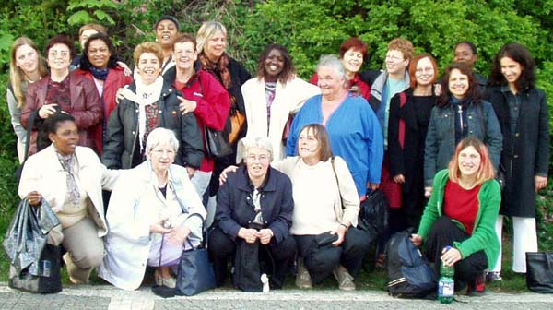

Photo from the planning meeting of partner organizations in May 04 in Prague

This project is supported by European Commission, Directorate General for Education and Culture

